SOKE's MESSAGE TO STUDENTS:
“THE WAY OF THE WARRIOR; THE WAY OF THE PEACEMAKER”

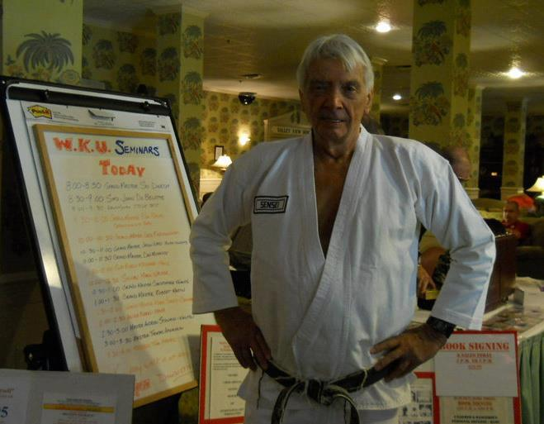

“My focus is PEOPLE, young people! Young people, have a quest to learn, to seek new questions; to discover new answers, not only to our beginnings, but to our future as well!" OPPORTUNITY---DISCOVERY--- LEARNING!, all of these areas are to be found in great abundance in the World we live on; the World we live in however, is oftentimes quite different. For many young people, they seem to have a sense of direction and purpose, while others flounder and encounter difficulty in growing up. I believe in a personal conviction which addresses a unique and different concept of our Nations most important "national resources."
“The "resources" are not to be found in our gold depositories, museums, or national archives, but rather, they are to be found in every household across this Land, and the "resources" are in the form of our people, young people in specific, into whose hands, one day, we will give the stewardship and the helm of our Ship of State. In our lifetime, young people of the present will become the adults of tomorrow; young people will become heads of households and homeowners. Young people will become parents and leaders in both the public and private sectors. Young people will become our tradesman, educators, scientists, and industrial leaders.”
“A young Brown Belt student of mine once told me that he chose not to enter the “Black Belt” tract at a particular time because he felt that he needed to know more about his basics before undertaking a more advanced course of training. He knew he wanted to earn the Black Belt, but he also knew how much more he had to learn in order to achieve his goal. I am pleased to say that the young man finally earned his Black Belt, and today he is known as Grandmaster John Spinks, 8 th Dan, Tai Shin Doh, from Seminole, Florida, Veteran of the United States Air Force, Vietnam, my student and successor to the Sokeship of Tai Shin Doh!”
And so, my final counsel to you;
TRUST IN GOD!
LISTEN TO THE ADVICE OF YOUR FATHER AND MOTHER!
TO THY OWN SELF BE TRUE!
And now, (young Student(s) I congratulate you on the start of your journey to seek opportunity, to discover, to learn, and to wish you well and long life in your sojourn to seek your WAY!;
I bid you welcome to the ranks of age old, respected and honored traditions as found in Karate!
GOD BLESS THIS GATHERING and GOD BLESS AMERICA!
Grandmaster Ronald F. Balas, Soke
Taishindoh. TaishinJitsu
Kidskarateworld.com
Rev: 3/2007 These ideas are only part of Soke Balas’s message. Edited by Grand Master Spinks

